Culture and market opportunity analysis
Institution
Course
Name

Features
Oppo Reno5 5G was released in January 07, 2021. The cellphone weighs 172g and has a thickness of 7.9mm. The body dimensions are 159.1*73.4*7.9 mm. its body has gorilla glass 5 at the back and front and it has an aluminium frame. It has dual SIM slots – nano-SIM. It has a wide display screen measuring 6.43 inches, 99.3cm² (GSMArena, 2020). It has a high resolution – 1080*2400 pixels. Its operating system is Android 11, ColorOS 11.1. It has no memory slot, but it has an internal memory of 128GB, 8GB RAM. The color is powerful – 64MP and a selfie camera of 32 mega pixels. Its battery can last for long as it has 4300 mAH and is non-removable (GSMArena, 2020). The phone has finger print sensors which makes it to be secure. The phone is going for $459.99 only.
Target Market
The target market of OPPO Reno5 mostly consists of young, urban, stylish people who like creative things. This will consist of middle- to –upper income earners since it is expensive. There are people who prefer premium devices and this are the ones who will consider purchasing Oppo Reno5 (Scott, 2018). The state of technology has really evolved over time and there is also another lot who could be described as tech savvy and will be also targeted as a viable market.
Market Potential of Cellphone
The cellphone market for India seems to be promising for the Chinese cellphones. This is a clear indication that OPPO Reno5 been a stylish phone will probably hit the market with a storm. Currently Oppo has a market share of 10.1%.
Fig. 1.0
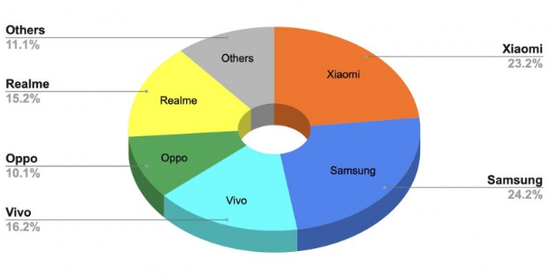
The Chinese cellphone brands – Oneplus, Vivo, Oppo and Xiaomi seems to be doing well in the Indian market. The Chinese smartphone brands account for 64% market share of the Indian cellphone market. The rest of the market- 36% has been taken up by Google, Apple, Asus, Samsung and others as indicated in the figure above. The Indian Cellphone market seems to be promising for Oppo Reno5. The market share of the Chinese smartphones seems to have been declined by the fact that back in 2020 there was anti-China sentiments which were issued by some leaders such as the former U.S. President, Donald Trump.
Effect of Culture on Marketing of Cellphones
Religion appears to be playing a central role in Indian society as well as culture. It has also be seen to influence businesses and the general economy of the country. Any business startup must have considered the different religions – Hindu, Christianity, Islam and others – who are found within the Indian market. Religion functions as a force that impacts business behavior. At some other point, it can act as a regulatory force and in so doing it results to affecting the businesses more directly (Stephanie, 2020). Language is another thing that needs to be considered when entering in the Indian cellphone market. Language poses a major challenge for businesses since there are 23 official languages that are used in India. What compounds the complexity of the issue of language is the fact that there are thousands of dialects which often replicates this experience within just one state. Many of the cellphones are equipped with English and this might render the cellphones useless.
Beliefs have been seen affecting the performance of businesses across the world. Thus, before a business enters a new market, it is important to consider the set of beliefs that they base on when making decision on what product to buy. People want to buy something that will help in making their life simple and better. With that having been said, the major belief in India that has been affecting the cellphone market is that of valuing apps (Scott, 2018). A significant portion of the smartphone users in India believe that mobile apps will truly result to benefiting their lives. Norms and behaviors have always been impacting businesses in India. For instance, it is a common behavior for Indians not to criticize their bosses and this could be replicated to the mobile phones. They can result to avoiding criticizing the cellphone yet it might be having issues that need to be attended. Such a move will result to its failure within the Indian market.
Social structure of India has acted to be a major challenge for the success of businesses within the country. The country has experienced some improvements in terms of making income equality a reality. However, despite of India making some considerable progress in terms of bridging income inequality, still the country has continued to be an economically backward nation. Major part of India’s population has continued to live below the poverty line. This will act as a major barrier for the success Oppo Reno5.
Hofstede’s model of cultural dimensions are as follows:
Power distance Index
Power distance index refers to the degree of inequality that exist between individuals with and without power. The Indian society appears to be having a high PDI score meaning that they have accepted an unequal, hierarchical distribution of power and that they understand their place within the system (Hofstede, & Hofstede, 2004).
Individualism VS. Collectivism
Individualism versus collectivism indicates the strength of the ties that individual have to others in the society. The Indian society appears to be a collectivist since they appear to be loyal to the groups that they belong to (Hofstede, et al., 2004).
Masculinity Vs. Femininity
This is the distribution of responsibilities and roles between women and men in the society. The Indian society is a masculine society as the roles of men and women have been seen to overlap less.
Uncertainty Avoidance index
This is a measure that is used to describe how well individuals can cope with anxiety. The Indian society appears to have a high score for uncertainty avoidance since the Indians attempts to make their lives as predictable and controllable as possible (Raza, 2018).
Time
This refers to the time horizon that is displayed by people belonging to a certain society. There are people who are concerned with a long-term orientation and they tend to be modest, pragmatic and more thrifty (Raza, 2018). There are some other people who are concerned with short-term and they tend to emphasize more on truth, consistency and principles.

References
GSMArena. (2020). Oppo Reno5 5G. gsmarena, Retrieved from: https://www.gsmarena.com/oppo_reno5_5g-10589.php.
Hofstede, G., & Hofstede, G. J. (2004). Cultures and Organizations. Blacklick: McGraw-Hill Publishing.
Raza, M. (2018). Impact of Hofstede's cultural dimensions on the Human Development Index of European countries: Longitudinal time series analysis, secondary research.
Scott, S. (2018). OPPO targeting young, urban consumers with Reno brand in GCC. Gulf News, Retrieved from: https://gulfnews.com/technology/consumer-electronics/oppo-targeting-young-urban-consumers-with-reno-brand-in-gcc-1.64476368.
Stephanie, M. (2020). What is Demographic Segmentation . Instapage, Retrieved from: https://instapage.com/blog/demographic-segmentation#:~:text=Demographic%20segmentation%20divides%20the%20market,defined%20group%20within%20that%20market.

